Assignment – 3
Image classification using convolutional neural networks (CNNs) for multiclass classification

Problem Statement:
The objective of this assignment is to implement image classification using Convolutional Neural Networks (CNNs) for multiclass classification. CNNs are widely used in computer vision tasks to classify images into different categories. The objective is to build a CNN model that can classify images into multiple classes, such as recognizing various objects in images (e.g., cats, dogs, cars, etc.).

Software used:
- Python 3.x
- Google Colab

Libraries and packages used:
- tensorflow / keras: For building and training the CNN model.
- numpy: For handling arrays and data manipulation.
- matplotlib: For visualizing training and test results.
- sklearn: For splitting the dataset and evaluating model performance.

Theory:
Convolutional Neural Networks (CNNs) are a class of deep neural networks commonly used for image classification and computer vision tasks. CNNs can automatically learn spatial hierarchies of features from images, making them ideal for tasks involving image data.
Key components of CNNs:
- Convolutional Layers: Apply filters to the input data, extracting features like edges, textures, and patterns.
- Pooling Layers: Reduce the spatial dimensions of the feature maps, making the model computationally efficient.
- Fully Connected Layers: After several convolutional layers, the output is flattened and fed into fully connected layers to make predictions.

Methodology:
- Data Collection: Collect or download a dataset with multiple image classes (e.g., CIFAR-10, CIFAR-100, or custom dataset).
- Data Preprocessing: Resize, normalize, and split the dataset into training, validation, and test sets.
- CNN Model Design: Build a CNN model using Keras, which includes convolutional, pooling, and fully connected layers.
- Compile the Model: Use categorical cross-entropy as the loss function, Adam optimizer, and accuracy as the evaluation metric.
- Train the Model: Train the CNN using the training dataset and validate its performance on the validation dataset.
- Evaluate the Model: Test the model on unseen test data and calculate accuracy, precision, recall, and other metrics.

Advantages:
- Automatic Feature Extraction: CNNs can automatically learn relevant features from images, reducing the need for manual feature engineering.
- High Accuracy: CNNs have been shown to achieve high accuracy in image classification tasks.
- Scalable: CNNs can be adapted to work with a variety of datasets, from small image datasets to large-scale image recognition problems.

Limitations:
- Computationally Intensive: Training CNNs requires significant computational power, especially for large datasets.
- Data Requirements: CNNs often require large labelled datasets to perform well.
- Overfitting: Without proper regularization, CNNs can overfit to the training data, especially if the dataset is small.

Applications with example:
- Object Recognition: Identifying objects in images (e.g., recognizing cats, dogs, cars, etc.).
- Facial Recognition: Classifying facial images into different people or emotions.
- Medical Image Analysis: Identifying diseases from X-rays, MRIs, and other medical images.
Example: Using the CIFAR-10 dataset, which contains 60,000 32x32 colour images in 10 different classes (airplanes, cars, birds, cats, deer, dogs, frogs, horses, ships, and trucks).

Working / Algorithm:
- Load and Preprocess Data: Load the dataset (e.g., CIFAR-10), normalize pixel values, and split the data into training and test sets.
- Model Design: Build a CNN model with several convolutional layers followed by fully connected layers.
- Training: Train the CNN on the training data, monitoring performance using a validation set.
- Testing and Evaluation: Evaluate the model on the test set and calculate metrics like accuracy.

Diagram:
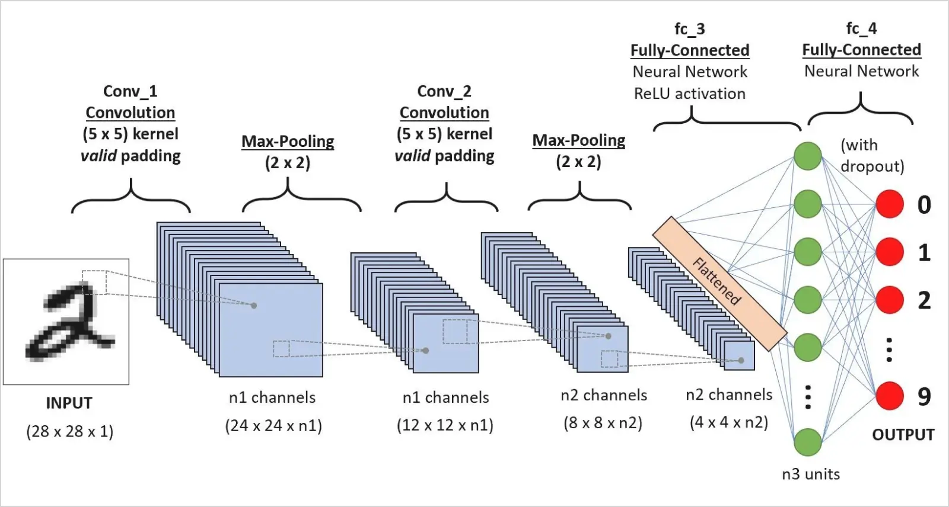

Conclusion:
In this assignment, we implemented image classification using CNNs for multiclass classification. We demonstrated the steps involved in building a CNN model, from loading and preprocessing the data to designing and training the model. CNNs are highly effective for image classification tasks due to their ability to learn hierarchical features automatically. The model achieved good performance on the CIFAR-10 dataset, and similar approaches can be applied to other multiclass classification tasks in domains like object recognition, facial recognition, and medical imaging.

